- Execute the Postman API requests sequentially in the order specified below.
  - RLP Token
  - Create Fields (Use attached files for fields)
  - Import GenerateSignComposer Custom Code (use attached custom code zip file)
  - Import CongaSignCallbackPalmetto Custom Code (Use attached custom code zip file)
  - Create API Resource For GenerateSignComposer
  - Create API Resource For CongaSignCallbackPalmetto
  - Create Resource URL Entries For GenerateSignComposer
  - Create Resource URL Entries For GenerateSignComposer Internal
  - Create Resource URL Entries For CongaSignCallbacksss
  - Register Conga Sign Callback
  - Insert Internal Template 2
  - Insert Internal Contract Template
  - Insert Solar Contract Template
  - Insert MSA Template
- Navigate to Migration Managerimport Package and upload QueryTerms.zip file to create object structure.
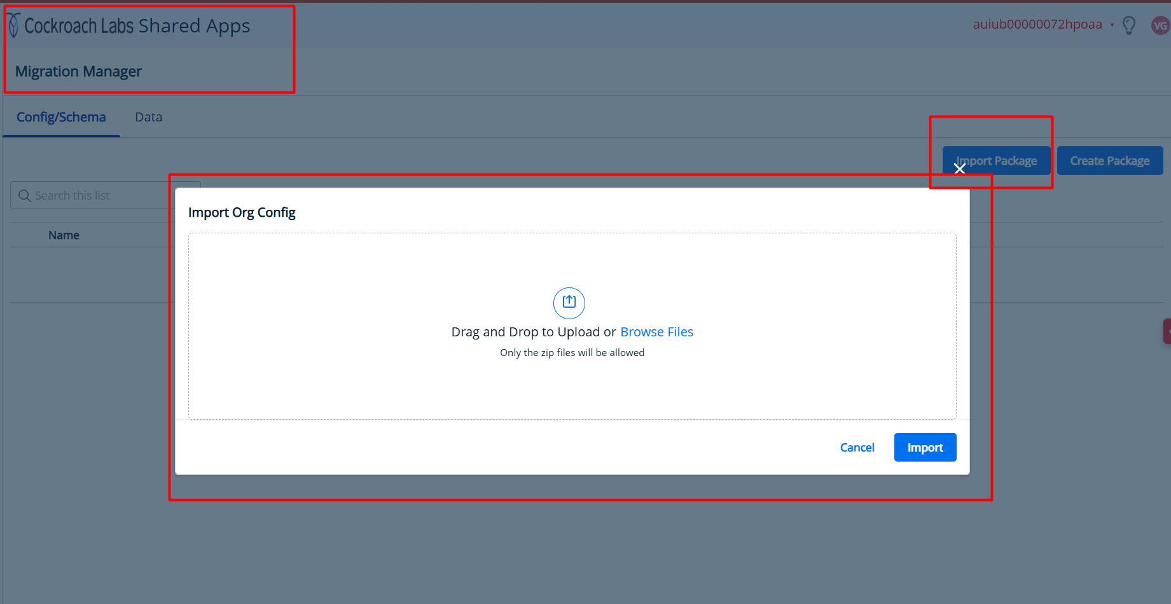
- Add Modify All permission for QueryTerms_c object in current user permission group.
- Change Client Id, Client Secret & Auth url in .env file(RuleBuilder_ReactAPP). Deploy React App and get deployed url or To Test it locally run npm install --force and then npm start.
Note: If your client secret has $ e.g, ($h) then add escape character before dollar (\$h).
- Navigate to Admin ConsoleApplication ManagerAppNewApp. In URL add //{{Deployedurl}}(remove https: as shown in screenshot) in Group Add Contract AppsSave.
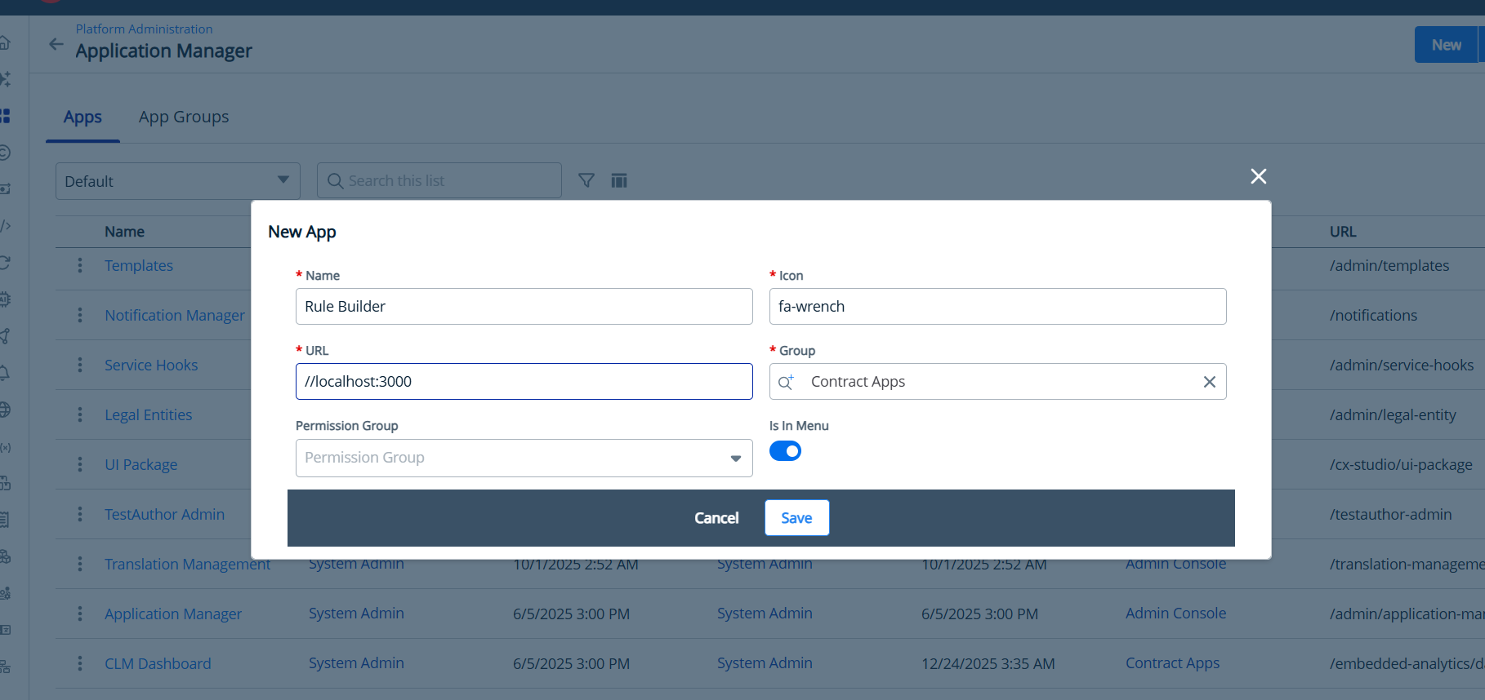
- Create 2 Button on Layout with following url:
  - SignComposerDocument: {{DeployedURL}}/Generateandsign/{recordId}
  - SignComposerDocumentInternal: {{DeployedURL}}/GenerateandsignInternal/{recordId}
[
{
"id": "SignComposerDocument",
"key": "SignComposerDocument",
"label": "Sign Composer Document",
"actionFunc": "navigate",
"customAction": {
"displayName": "Sign Composer Document",
"name": "navigate",
"actionDef": "async function(e){var t;const r=null===(t=e.CCL)||void 0===t?void 0:t.customCodeService,{resourceName:n,method:i,url:a}=e.params,o={resourceName:n,method:i,requestParam:{...e.context,userInfo:e.userInfo,orgInfo:e.orgInfo},url:a};let s;try{s=await(null==r?void 0:r.executeUri(o))}catch(e){return Promise.reject(e)}return s||{Data:{respAction:[],data:{}}}}",
"source": "ccl",
"params": "url:https://localhost:3000/Generateandsign/{recordId}"
},
"hidden": false,
"selected": false
},
{
"id": "SignComposerDocumentInternal",
"key": "SignComposerDocumentInternal",
"label": "Sign Composer Document Internal",
"actionFunc": "navigate",
"customAction": {
"displayName": "Sign Composer Document Internal",
"name": "navigate",
"actionDef": "async function(e){var t;const r=null===(t=e.CCL)||void 0===t?void 0:t.customCodeService,{resourceName:n,method:i,url:a}=e.params,o={resourceName:n,method:i,requestParam:{...e.context,userInfo:e.userInfo,orgInfo:e.orgInfo},url:a};let s;try{s=await(null==r?void 0:r.executeUri(o))}catch(e){return Promise.reject(e)}return s||{Data:{respAction:[],data:{}}}}",
"source": "ccl",
"params": "url:https://localhost:3000/GenerateandsignInternal/{recordId}"
},
"hidden": false,
"selected": false
}
]
- Change TemplateId_MSA, InternalContractTemplate, InternalContractTemplate2 , CoreAppsUrl & InstanceURL in Constants.cs file in GenerateSignComposer custom code.
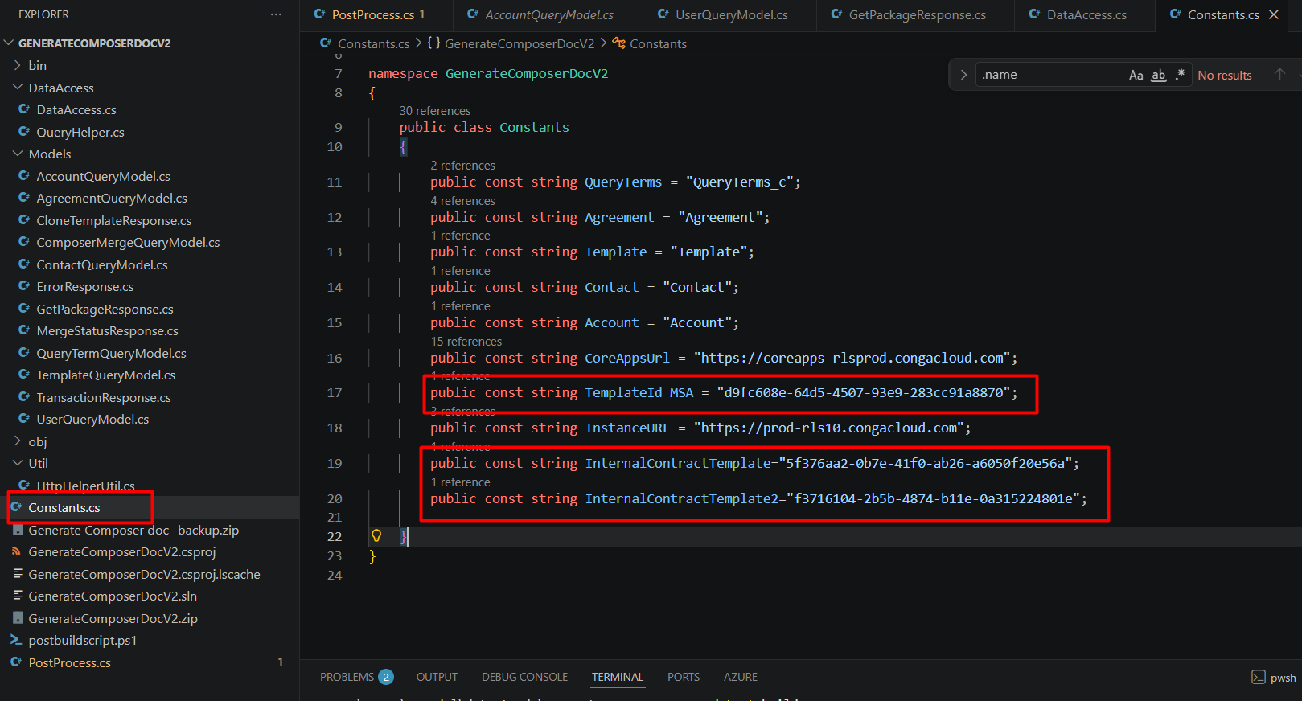
- Allow CRUD Operation For Agreement, Account, Contact, Template Objects under Trusted Object.
Note: Use Integration User Client Id & Integration User client secret wherever required.

